**Experiment No.: 2**

**Aim**

Familiarisation of Linux commands

**CO2**

Perform System Administration tasks.

**Procedure**

read

To read a content from the user

echo $reply

To display the content received from the user

$read

$echo $reply



read a b c

To read a content from the user and to store it to variables correspondingly

$read a b c

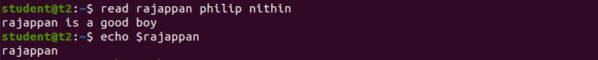

echo $var1 $var2

To display the content of the variable in the terminal

$echo $var1



read multiple line

by using “\” at the end of each lines

$ read

Nithin Jose\

Manjadiyil

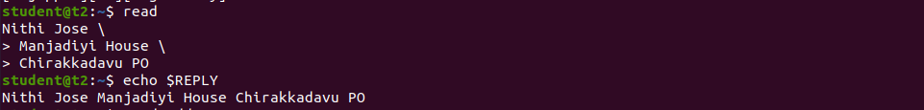

read -p

To prompt something to the user

$ read -p “Enter the input here :”



read -n 8 -p “Enetr the name”

To receive an input of fixed length from the user

$read -n 8 -p “Enetr your name”



read -s -p

To receive a secured input

$ read -s -p “Enter the Password”



wc

To display size elements of the file specified

$ wc profile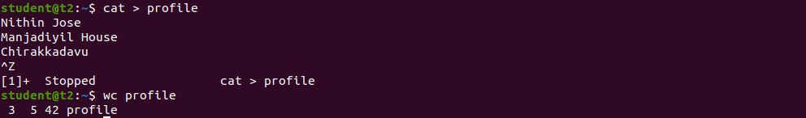

wc -l

To display the number of lines of the content

wc -m OR wc -c

To display the number of characters of the content

wc -w

To display the number of words in the content

$ wc -l

$ wc -m

$ wc -c

$ wc -w

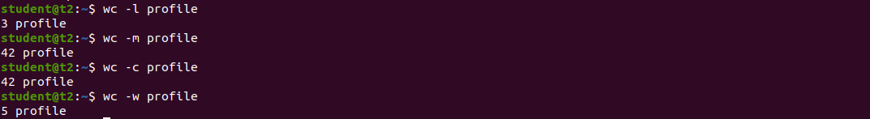

wc -L

To display the length of the largest line

$ wc -L profile



more

To display the content of large file fit to screen and outputs as user wants

$ more longtext.txt

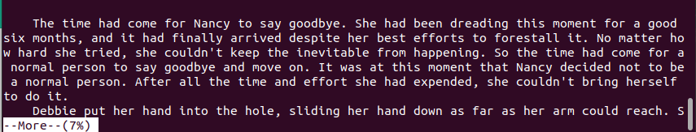

more +22 filename.txt

To display the content after a specified number of lines

$ more +22 lontext.txt

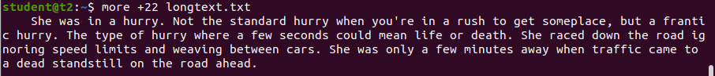

more +/pattern filename

To search for an instance and to start displaying from there.

$ more +/someplace longtext.txt

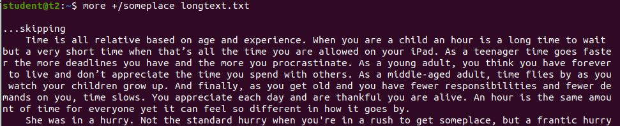

more -d filename

Help the user to navigate according to the instructions

$ more -d longtext.txt

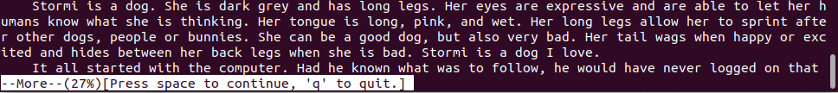

more -p filename

To clear the window and to display the content( Small files only)

$ more -p longtext.txt

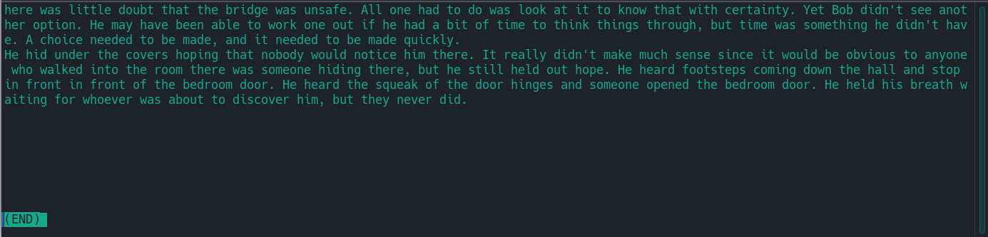

**Result**

The program was executed and the result was successfully obtained. Thus CO2 was obtained.